ECT583 Final – Online Game Store

# Introduction

* 1. CreditGateway

<http://ectweb2.cs.depaul.edu/ECTCreditGateway/>

Totally four gateway services are created, two for local and two for remote. And one for user registration and another for payment when placing order.

|  |  |  |  |
| --- | --- | --- | --- |
| **CreditAppId** | **CreditAppSharedKey** | **Local/Remote(Azure)** | **Usage** |
| 76 | D*QSQ*mHr* | Localhost | User Registration |
| 77 | $pO4sfN$s$ | Localhost | Place Order |
| 78 | HlbfORCa!t | Remote | User Registration |
| 79 | ithHz$dxTR | Remote | Place Order |

* 1. Roles

There are 3 different roles for this application, admin, advanced and regular.

* 1. Default User Account
* admin@gamestore.com / admin
* advanced@gamestore.com / advanced
* regular@gamestore.com / regular

# Pages

* 1. Home Page

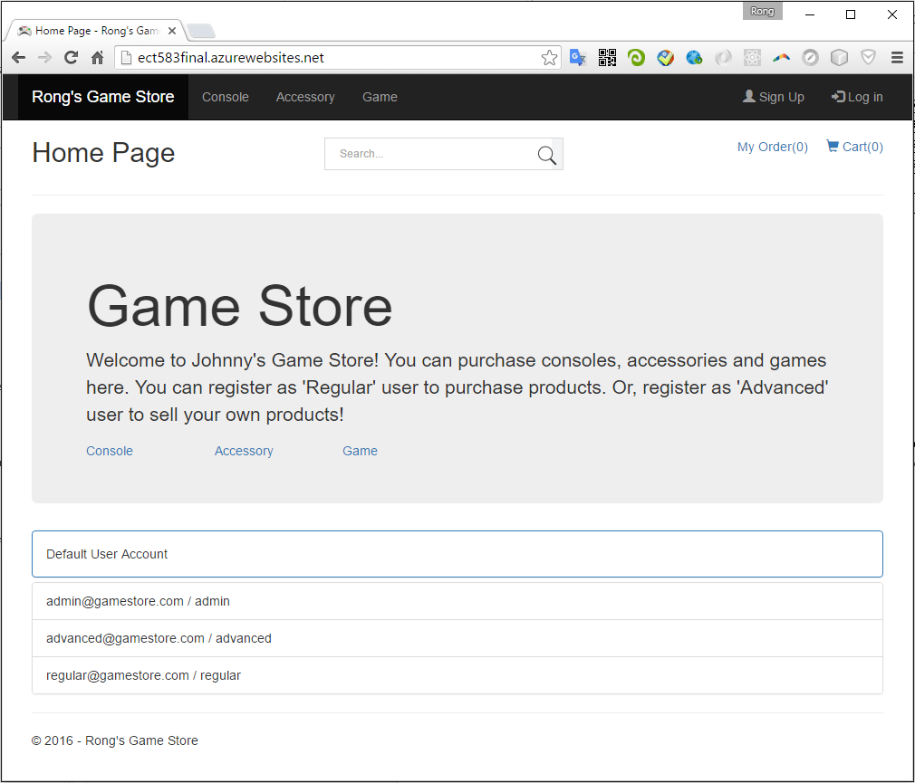

* 1. Consoles

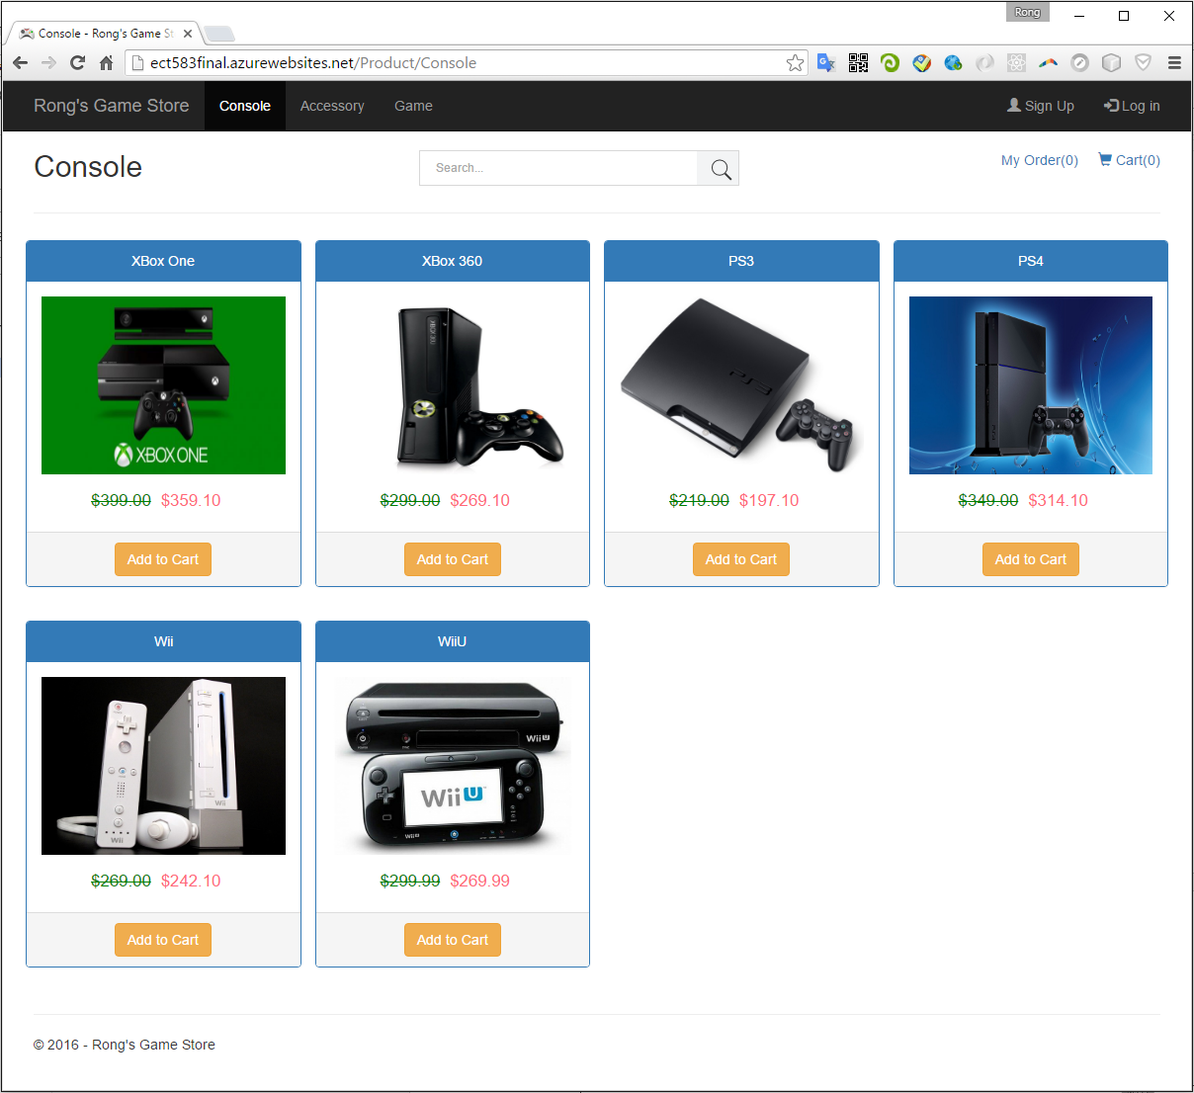

* 1. Accessories

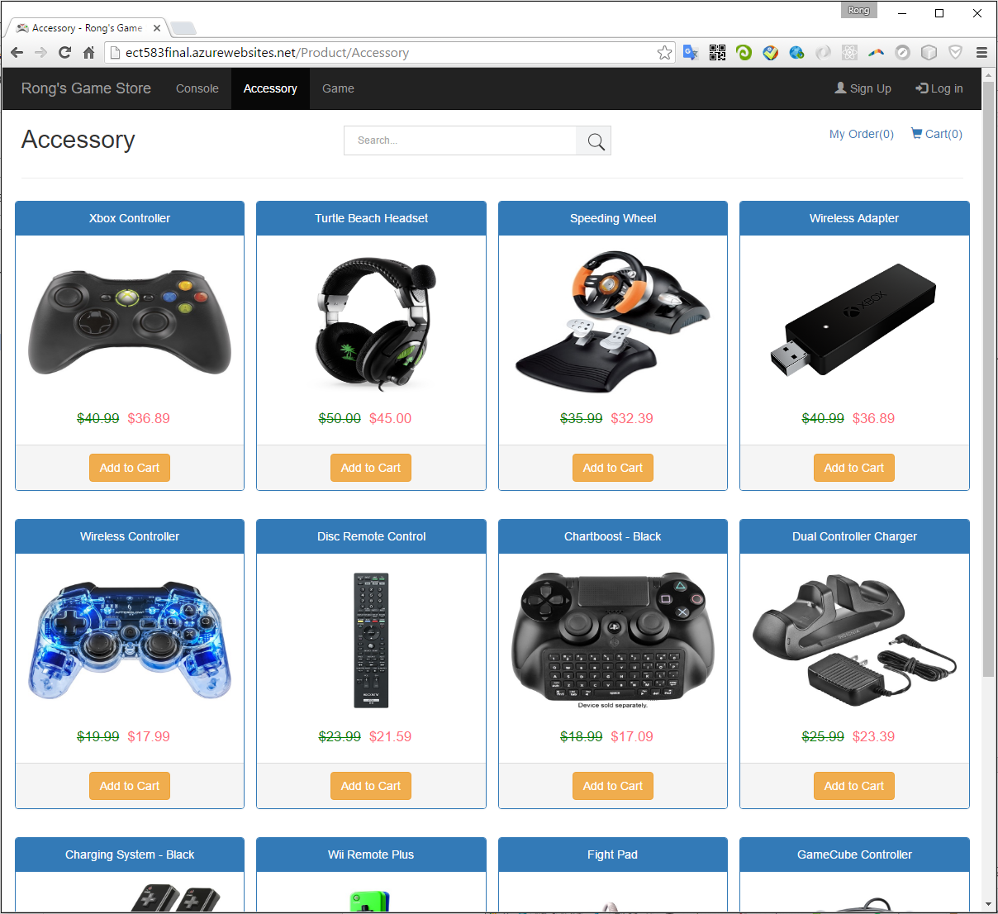

* 1. Games

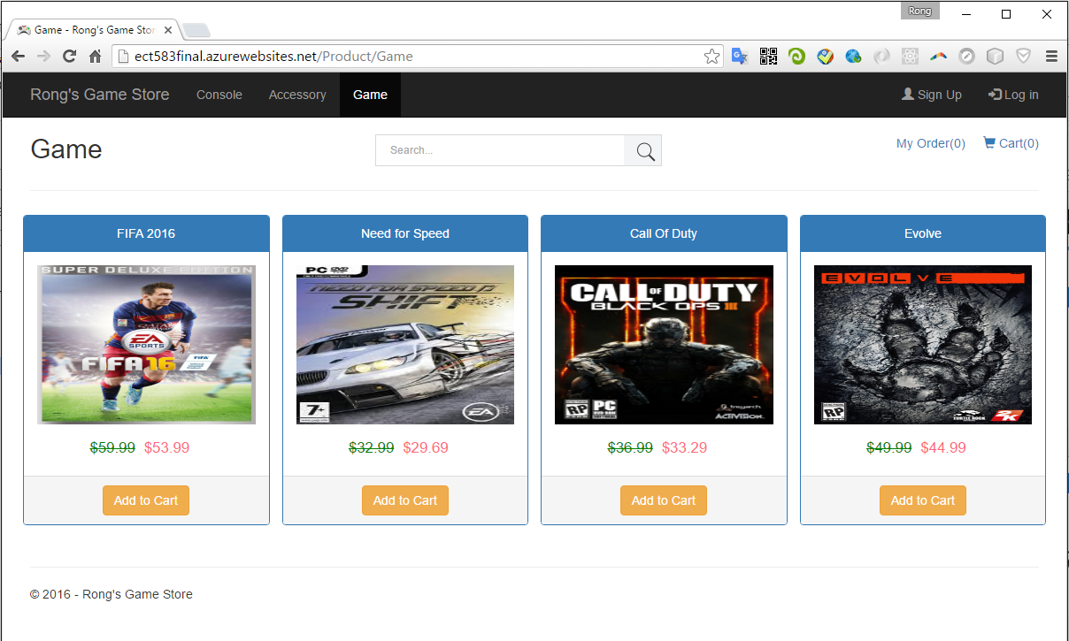

# General Functions

* 1. Search Products

1. You can search any product, including Console, Accessory and Game.

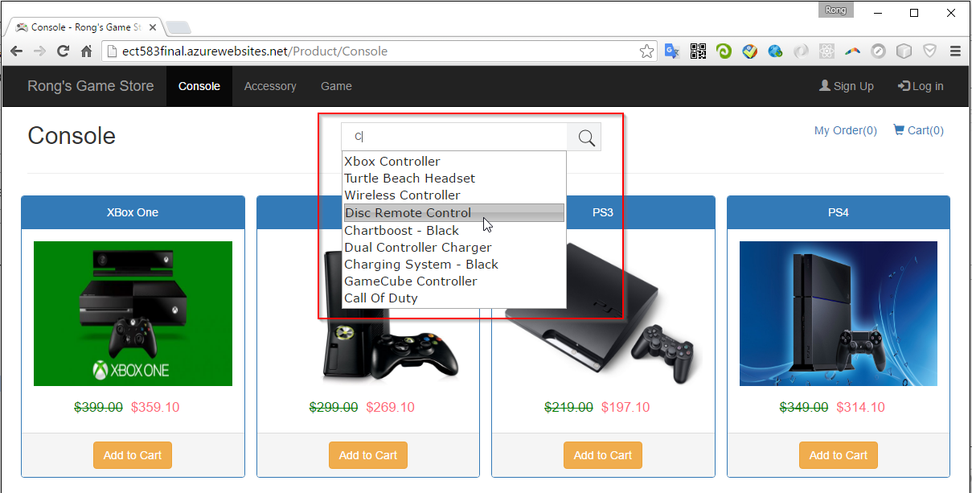

1. Auto complete is implemented.

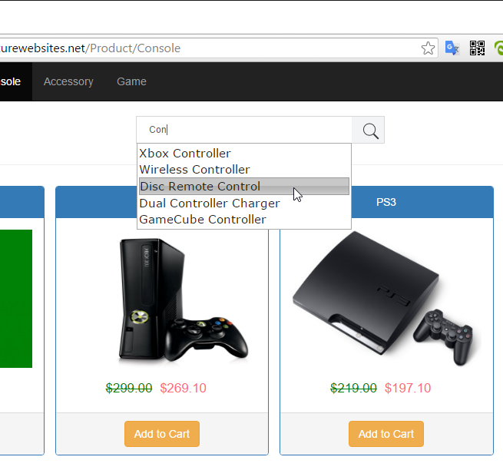

1. Search Results.

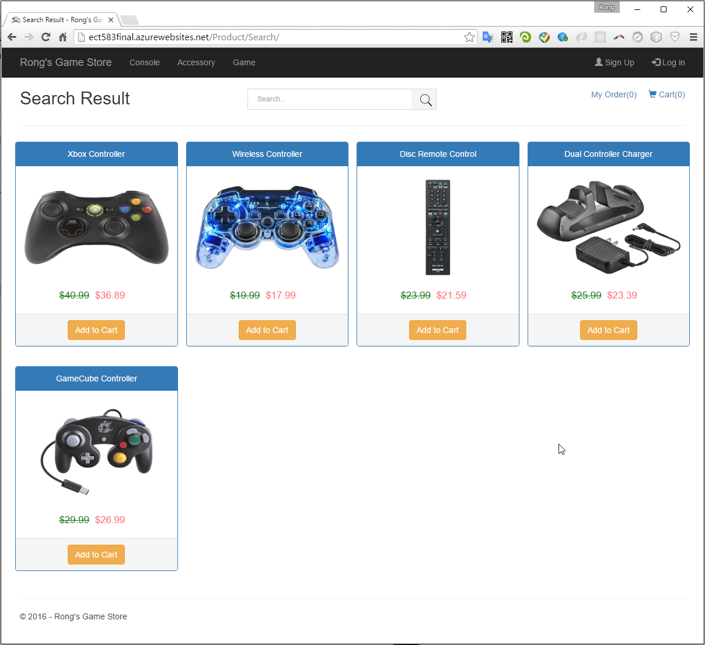

* 1. Register

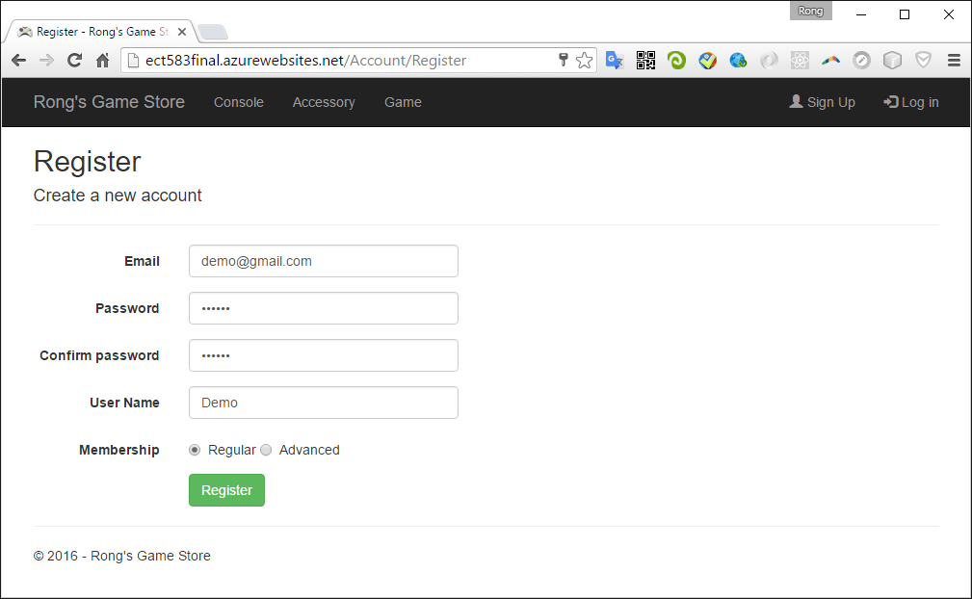

Redirect to Credit Gateway for payment.

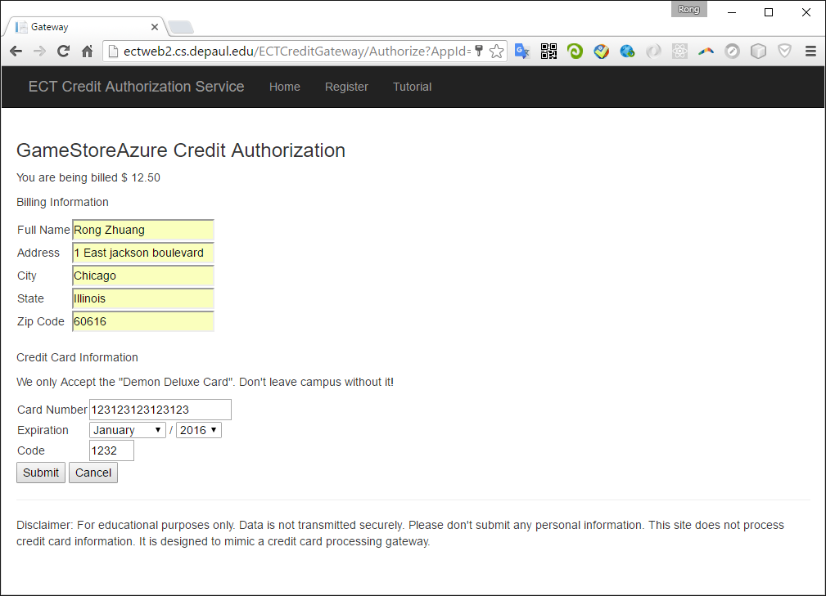

Return url: http://ect583final.azurewebsites.net/Account/ProcessCreditResponse

If credit gateway works properly, the new user will finish registration and login automatically.

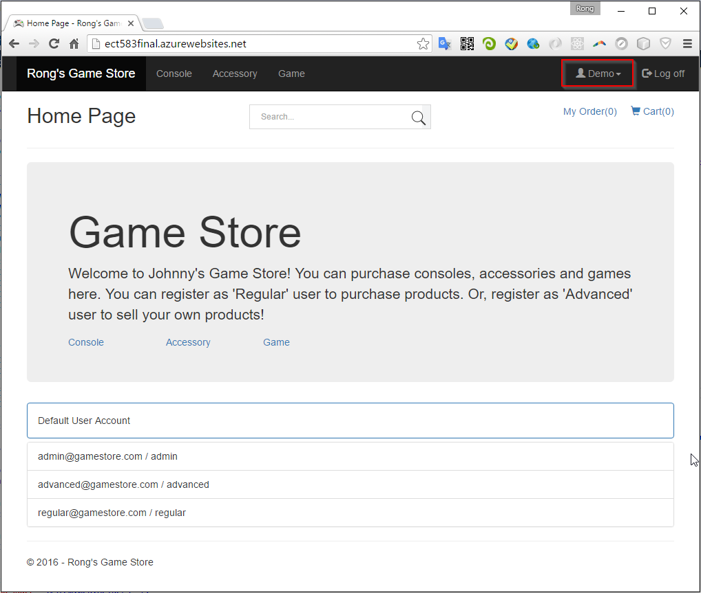

* 1. Login

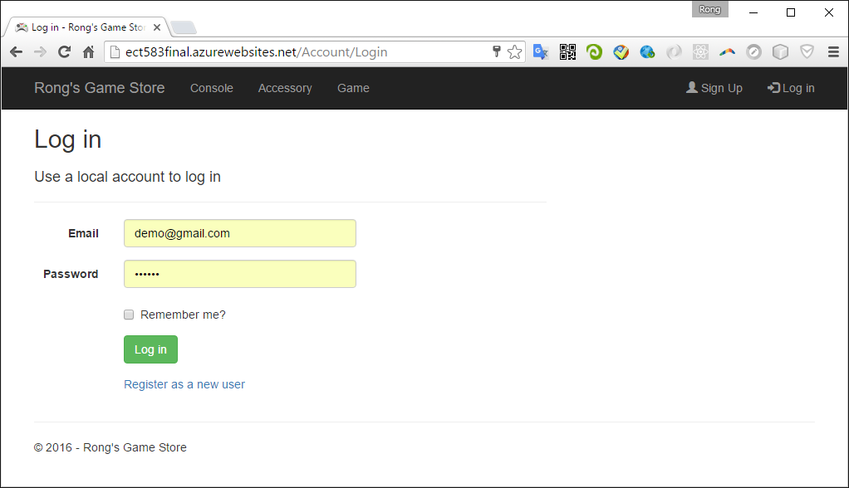

* 1. Profile

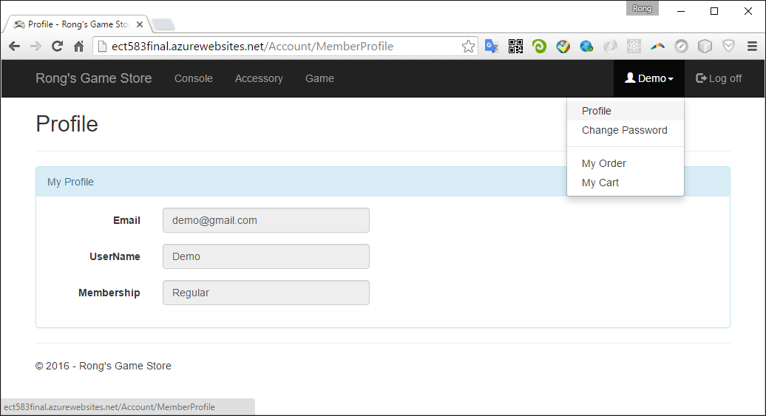

* 1. Change Password

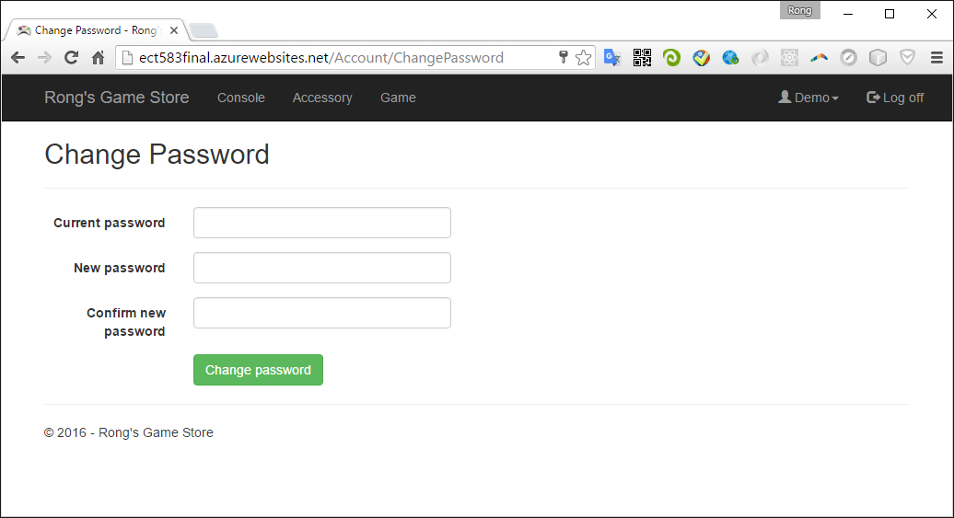

# Role-Based Functions

1. All the role based functions are available only for authorized user. You will be redirected to the login page if you try to access the unauthorized pages/functions.
2. After successfully login, the buttons at the top right of the webpage are changed. You username will be displayed and you can logout.
3. By the way, the original and discounted price are both shown for each product. Click ‘Add to cart’ button to add the current item to your cart.

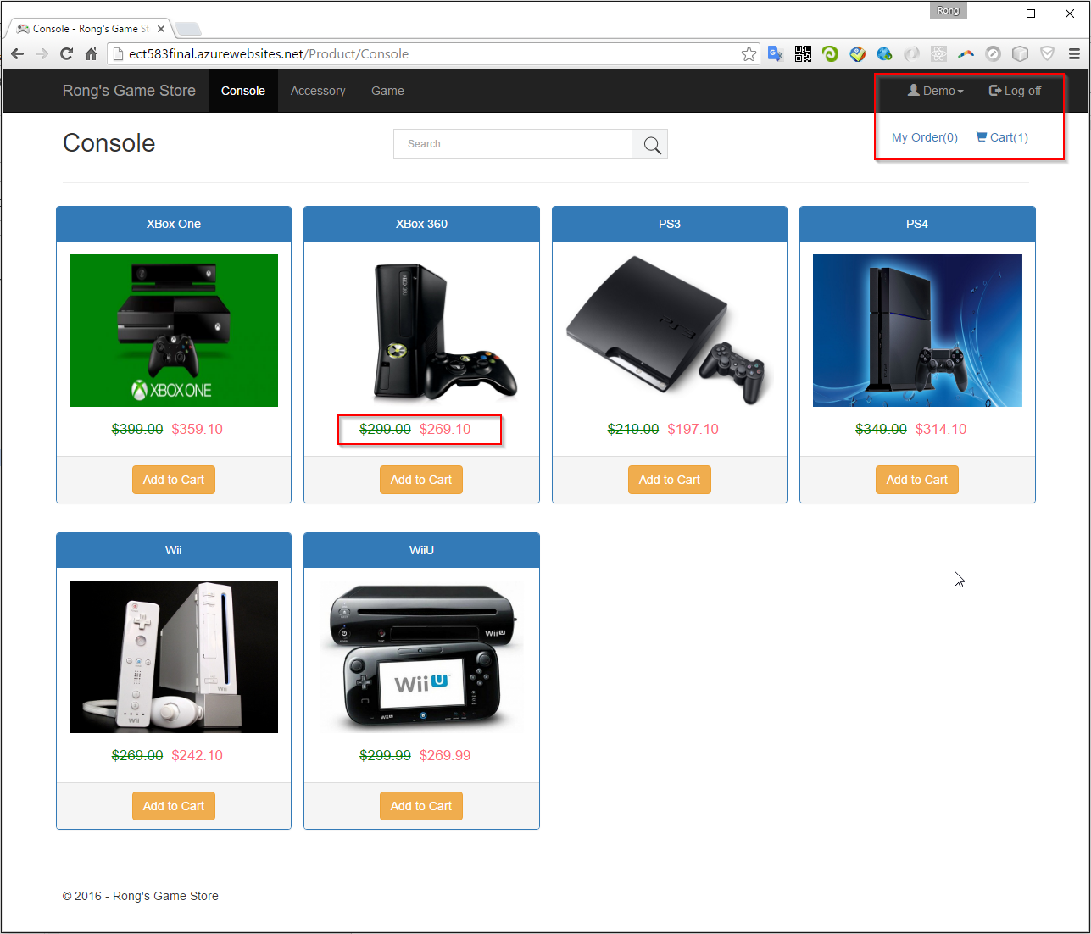

* 1. Regular User

Regular user can purchase products, add item to cart and place order finally.

* + 1. Cart

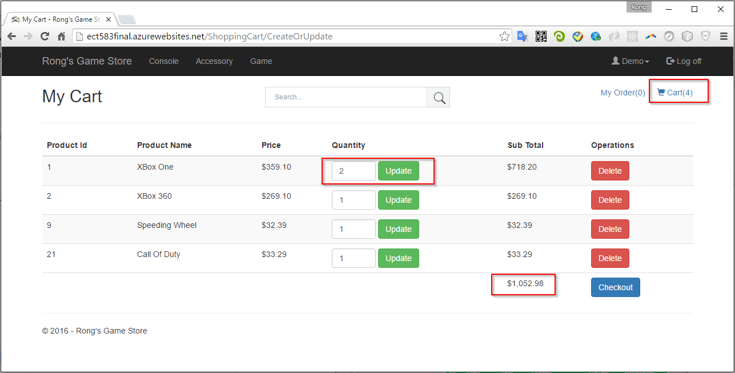

1. You can choose any product(console, accessory or game) added to your cart.
2. If any item added/removed from the cart, ‘Cart(n)’ will be refreshed immediately.
3. In the cart, you can update the quantity.
4. You can also remove the item.
5. The price is the discounted price.
6. The SubTotal shows the amount for each item cost(quantity may be larger than 1).
7. The Total shows the total amount cost of all items in this cart.
   * 1. Checkout
8. Provide the shipping information.

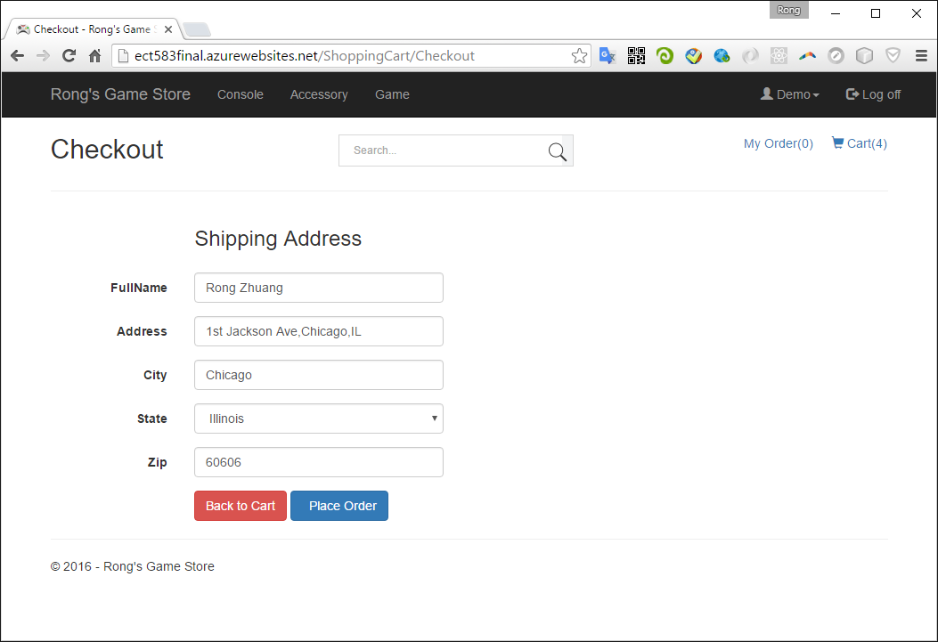

Go to another credit gateway for payment.

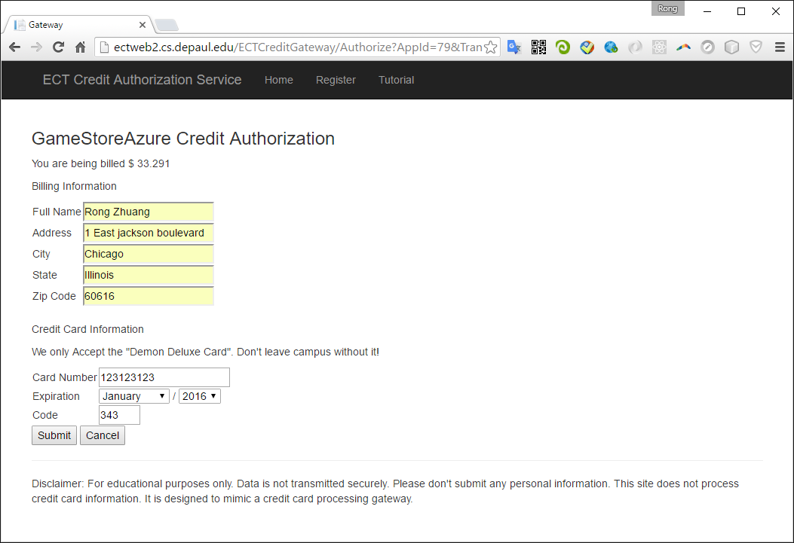

Return URL:http://ect583final.azurewebsites.net/ShoppingCart/ProcessCreditResponse

* + 1. Place Order

1. If successful with the payment, the items in cart are removed. Meanwhile, the order count is incremented by 1.
2. Confirmation Number is generated based on the current time: yyyyMMddHHmmss.
3. The delivery date is 2 weeks after the order date.

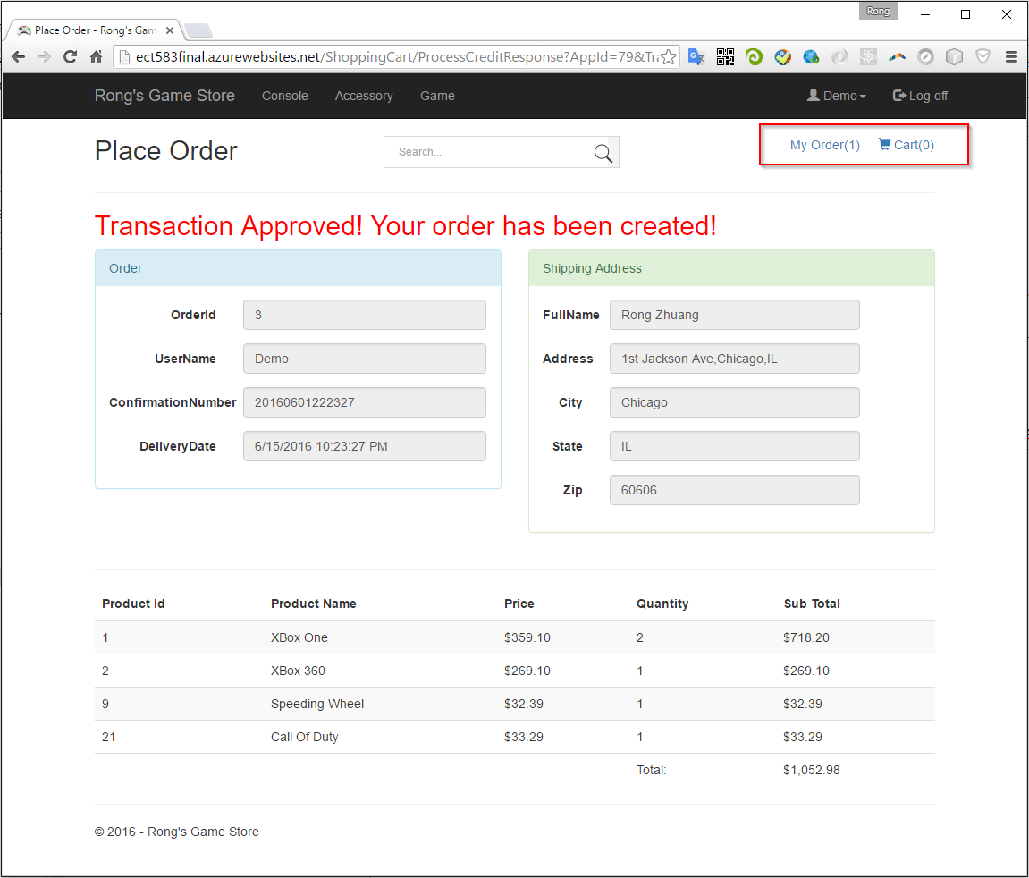

* + 1. My Order

1. Order list with detailed purchased items.
2. You can cancel the order here.

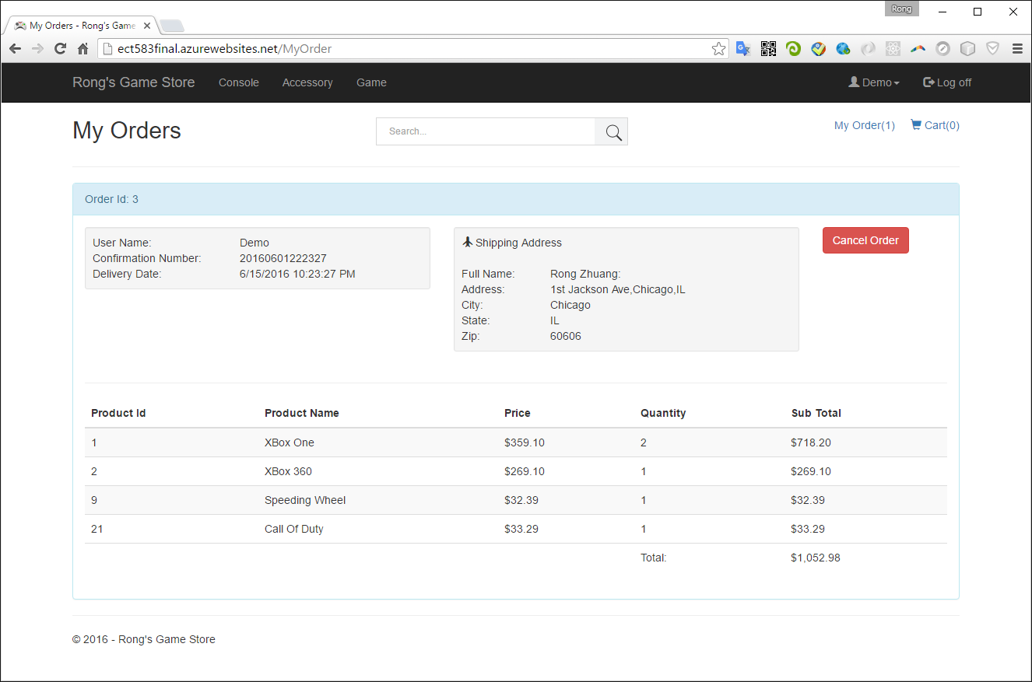

1. If there are multiple orders, all of them will be displayed, with detailed items and quantities.
   1. Advanced User
2. Login with the default user ‘storemanager’ and password ‘storemanager’.
3. After login, you will see two more different menu options: Accessory and Game.

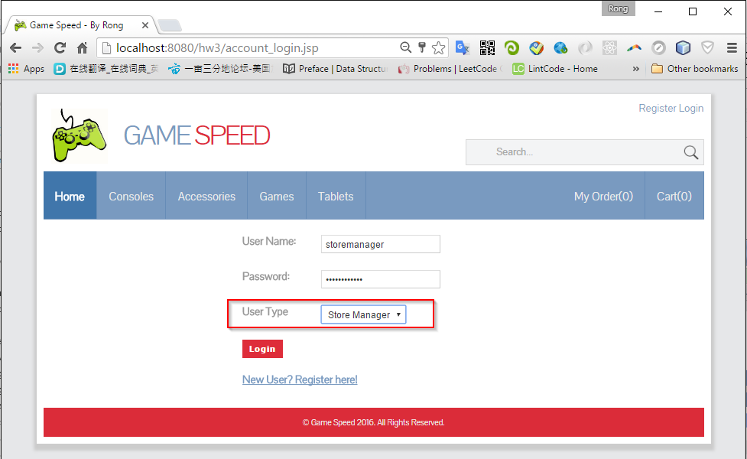

* + 1. Accessory

1. You can create, edit, and delete accessories.

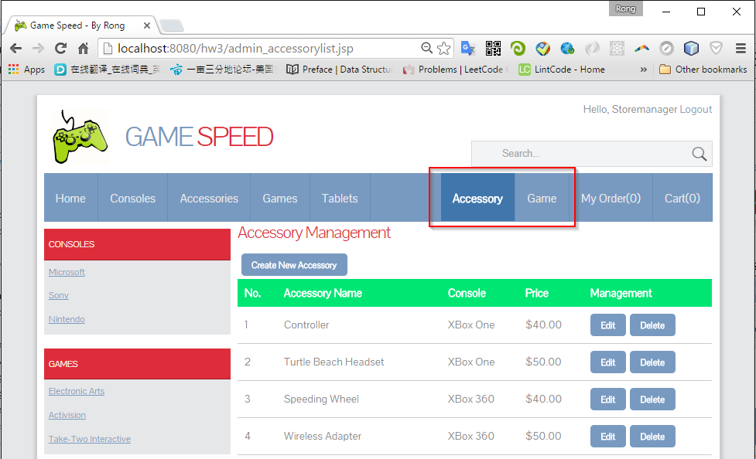

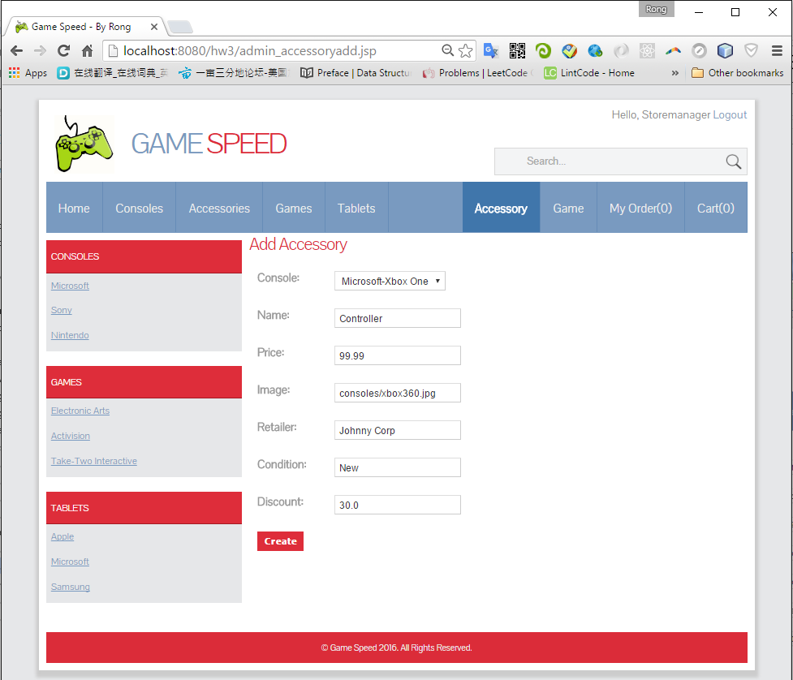

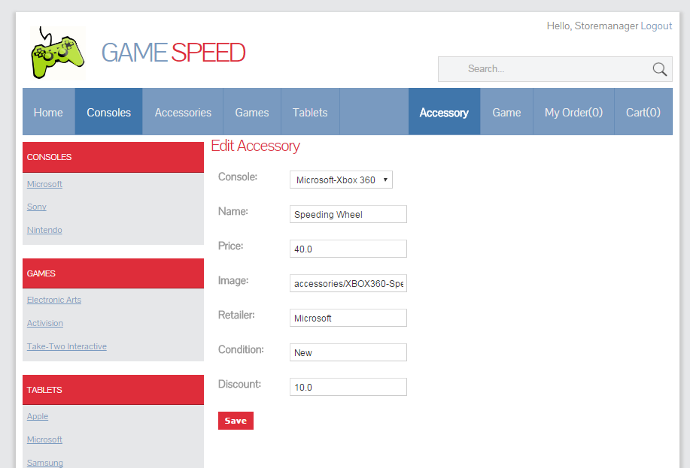

* + 1. Game

1. You can create, edit, and delete games.

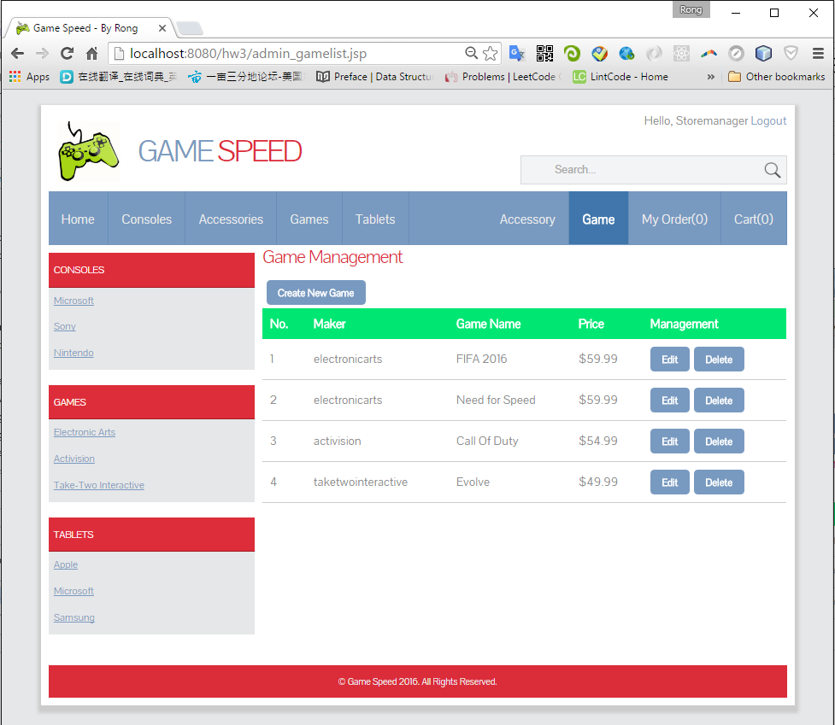

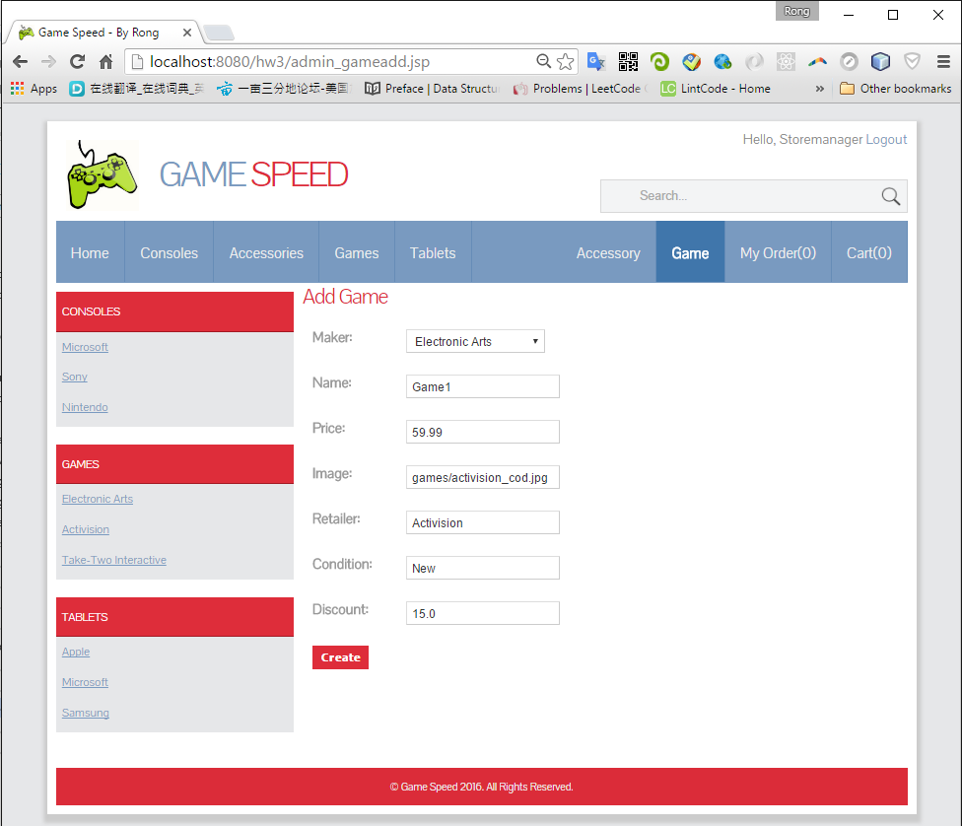

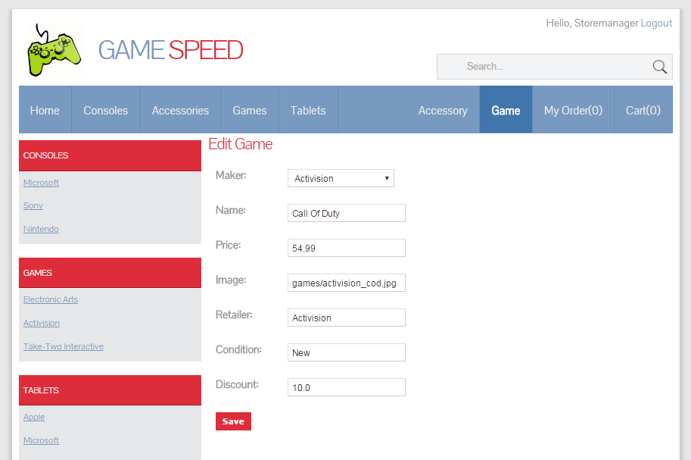

* 1. Salesman

1. Login with the default user ‘salesman’ and password ‘salesman’.
2. After login, you will see two more different menu options: All Orders and User.

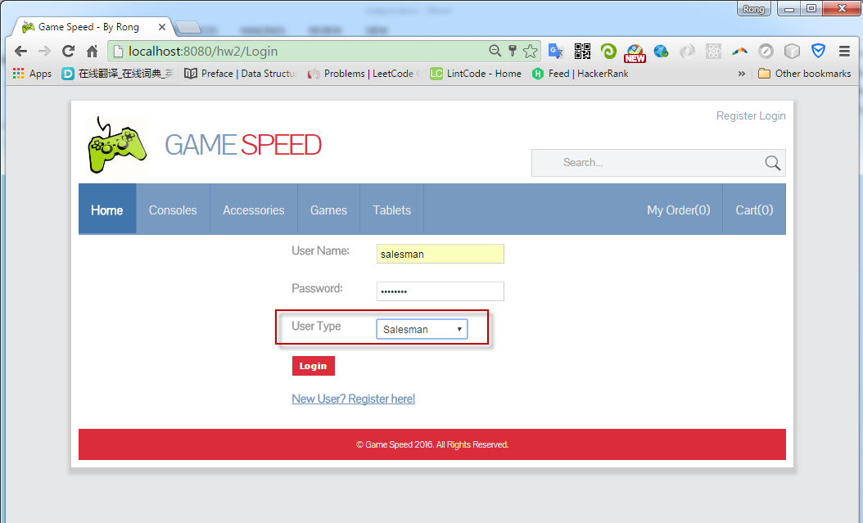

* + 1. All Orders

1. You can create, edit, and delete customers’ orders.
2. Different with ‘My Order’. ‘My Order’ only displays orders belong to current logon user. Here, it show all of the orders. ‘’All Orders’ is only authorized to ‘Salesman’.

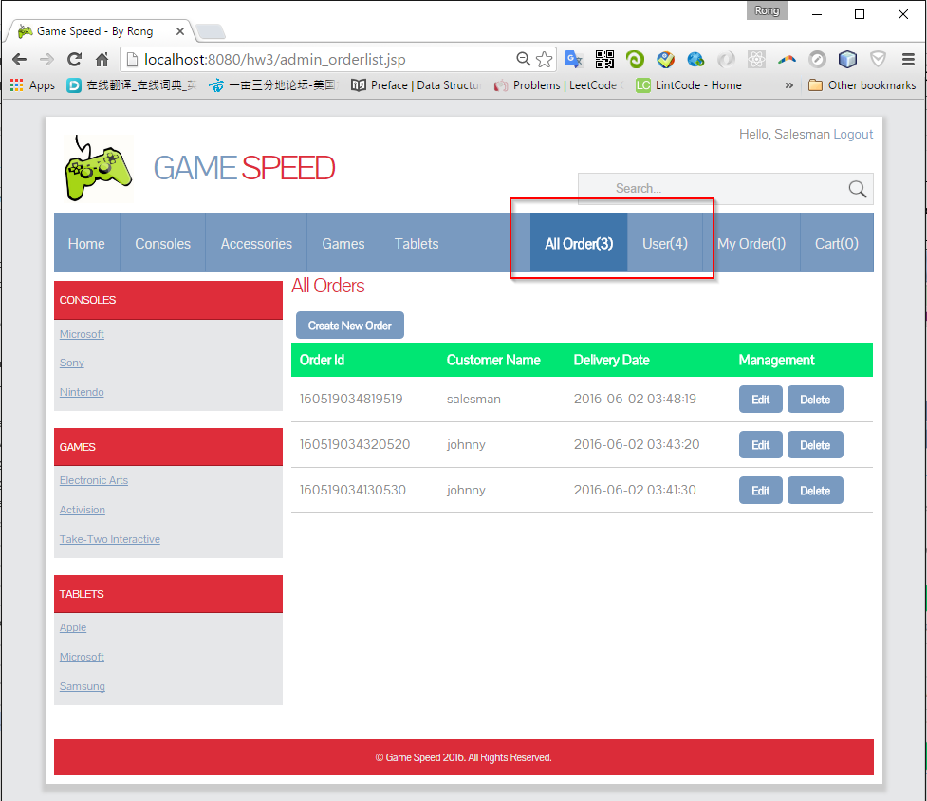

1. Create Order

Select user, provide address and credit card.

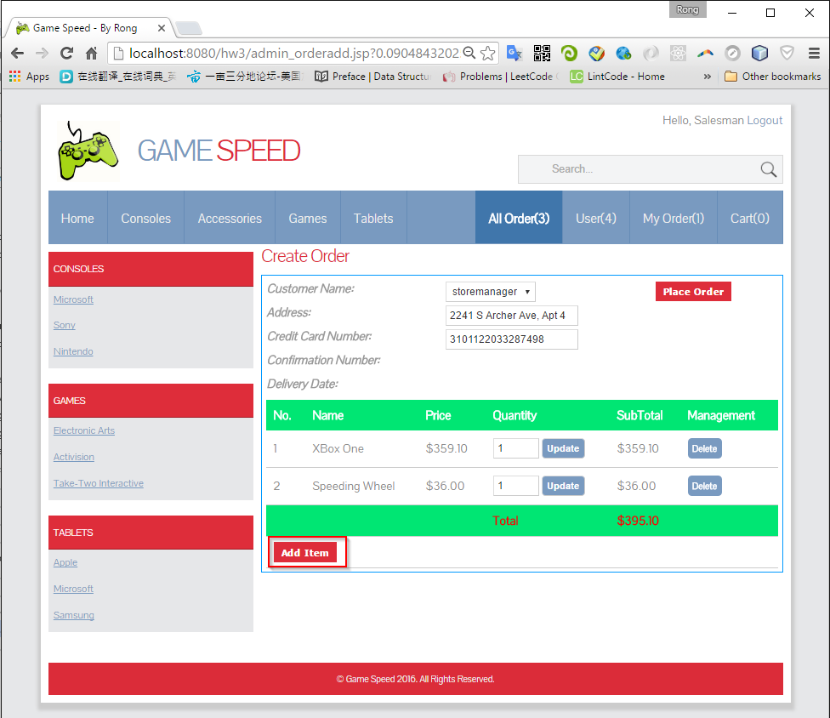

Use ‘Add Item’ to add new product to the order.

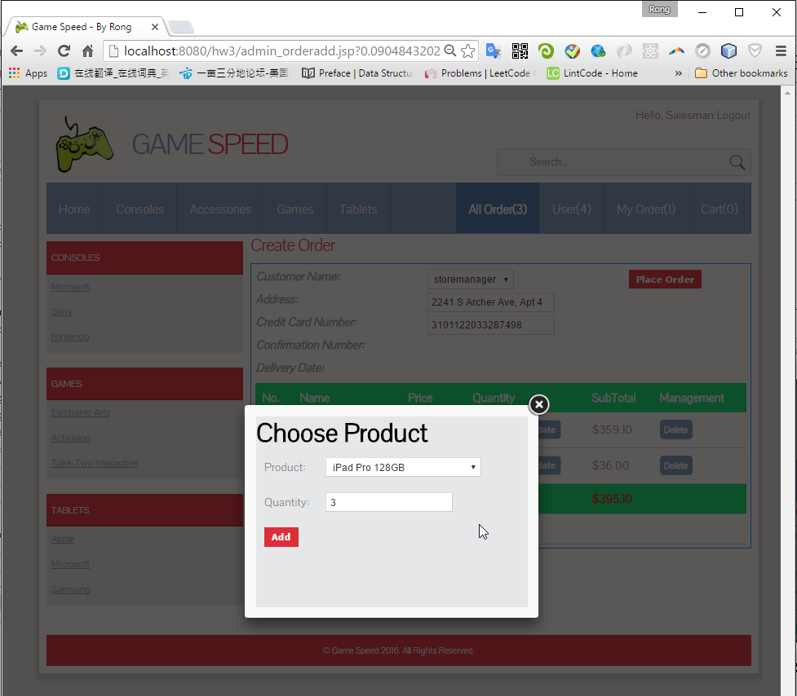

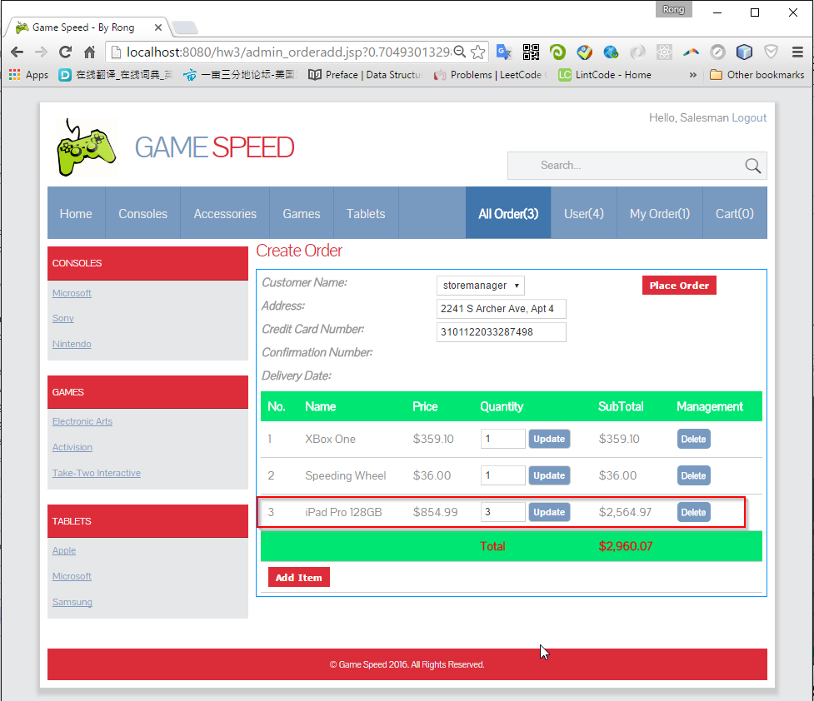

1. Edit Order

Edit address, credit card, Create new item, update quantity, delete item.

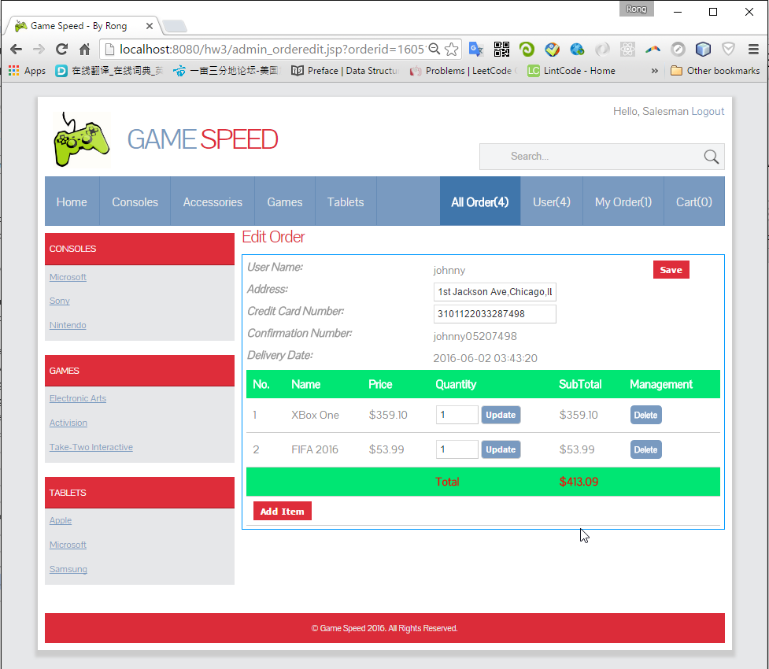

* + 1. User

1. You can create, edit, and delete users.
2. User Name must be unique, no matter what role.

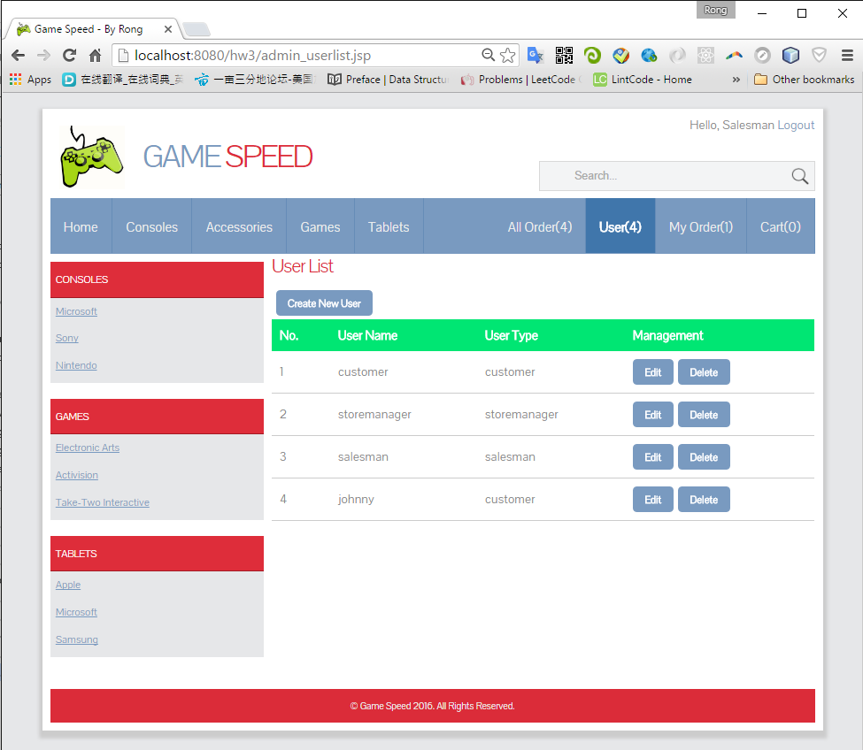

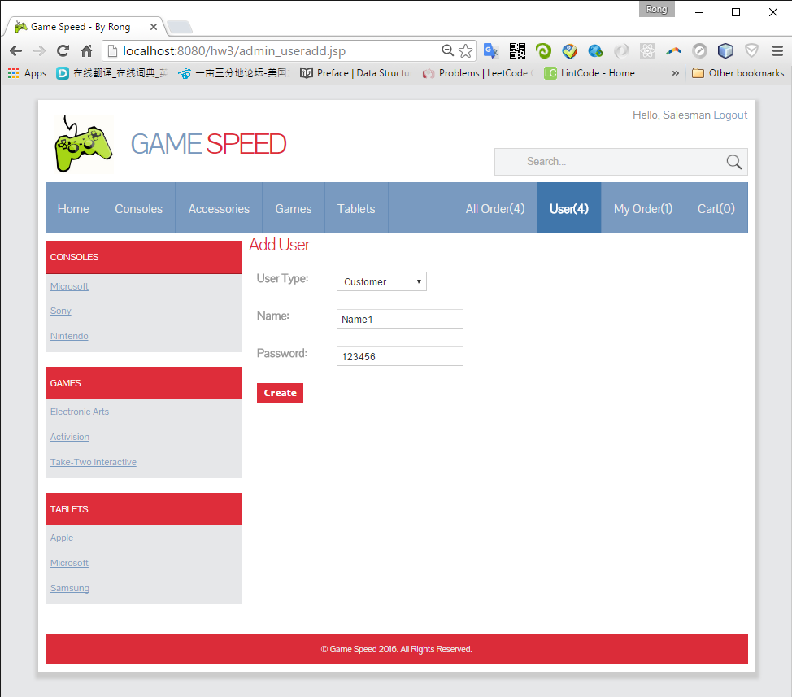

Only password is editable.

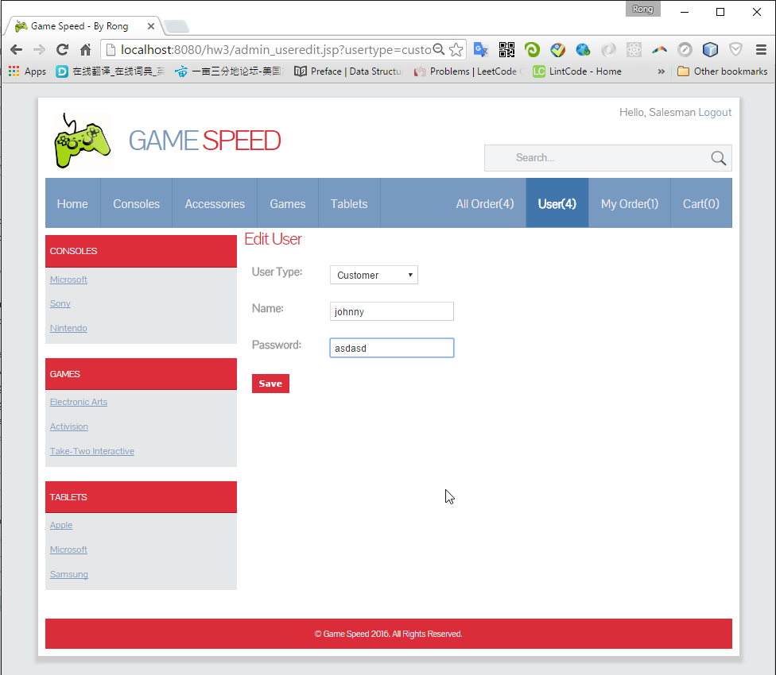

# Data Files

Products(consoles, games, tablets), Users and Orders are stored in serialized files.

